Vince Q. Villar DATA WRANGLING SCREENSHOTS

2-ECE-D ECE 2112

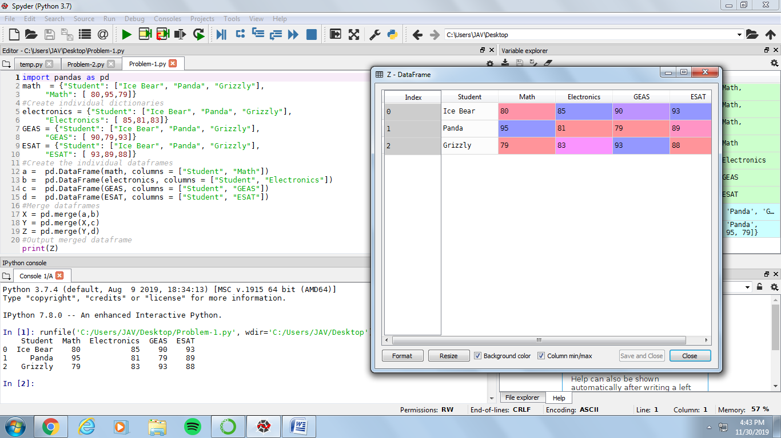PROBLEM 1

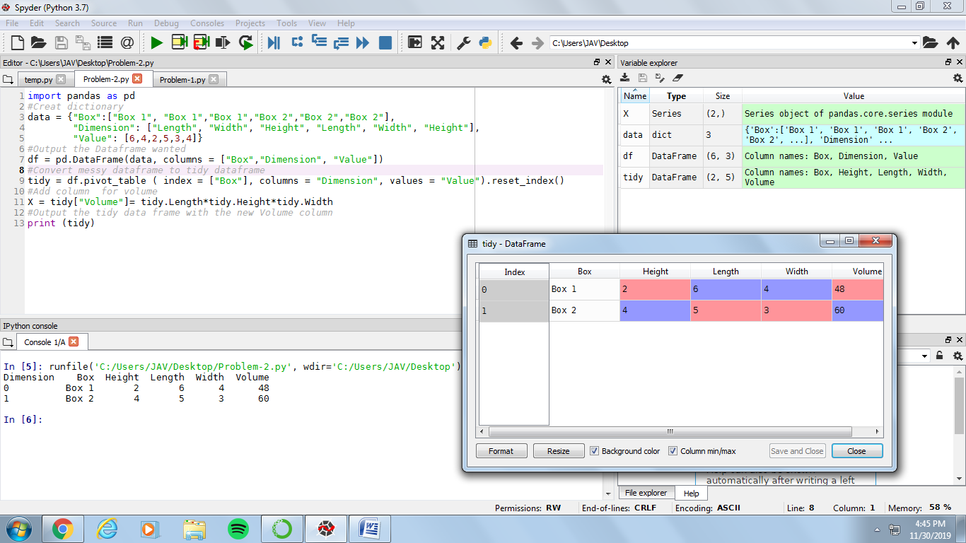PROBLEM 2